8.1.4 Editors - Image Editor - Header - Add menu
Image Editor - Add menu 2
Circle 2
Last Operator Add Circle 2
Size 2
Location X Y 2
Square 2
Last Operator Add Square 2
Size 2
Location X Y 2

Image Editor - Add menu

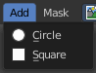
This menu just appears when you are in Mask mode.

In this menu you can create circle or square spline curves to use them for masking. They appear at the 2D cursor, and have four handlers.

They can be moved, rotated and resized with the usual W E R keys. See also mask menu, Transform. The handlers allows to change the shape and size too.

You can add multiple spline curves to a mask layer.

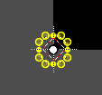
Circle
Adds a circle shaped spline curve.

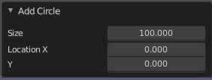
Last Operator Add Circle

Size
The size of the circle spline curve.

Location X Y
The location of the circle spline curve. Calculation happens from the center of the spline. 0 / 0 is down left.

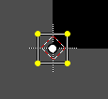
Square
Adds a square shaped spline curve.

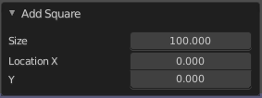
Last Operator Add Square

Size
The size of the square spline curve.

Location X Y
The location of the square spline curve. Calculation happens from the center of the spline. 0 / 0 is down left.

